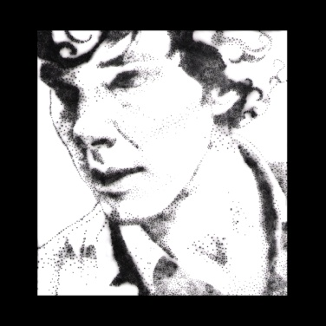
Push Pin Portraits
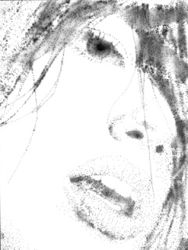
Materials:
- Portrait
- Matte Board
- Heavy Duty Tin Foil
- Clear Tape
- Push Pins
- Enlarger
- Photo Paper
- Darkroom Chemicals
Push Pin Process:
- Select a portrait from any of your available resources including self portraits, magazine ads, books or internet imagery. Choose photographs with good contrast and color. Images with drastic side lighting or shadows create unique end results.
- Try and select an image large enough to fit on an 8 x 10 sheet of paper.
- Stack your materials in the following order. Using clear tape create a hinge to keep them together. Be careful not to rip your tin foil!

Portrait on top

Tin Foil in the middle

Matte Board on the bottom

4. Focus on the shadow and detail areas of your portrait. Using a push pin, poke through the portrait, making sure to pierce the tin foil. Avoid making your holes too large and avoid outlining! Use implied lines to give the picture depth and detail.
Darkroom Process:
- Take only the tin foil into the darkroom.
Glass on Top
Tin Foil Portrait
Photo Paper Shinny Side Up
Enlarger Baseboard

- Printing Push Pin Portrait: Light = Brightest setting Print = 10 seconds Develop
Adjust time as needed.
- Making negative and positive prints form your paper (not tin foil) portrait. Same process as above except:
Negative Print: Light = Three clicks down Print = 10 seconds Develop
Positive Print: Light = Brightest light Print= 10 seconds Develop

