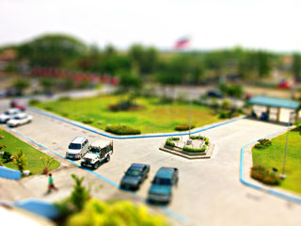
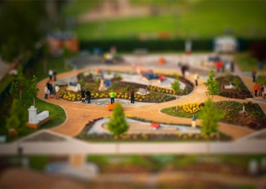
Tilt-Shift Photography
Tilt-shift photography refers to the use of camera movements on small and medium format cameras, and sometimes specifically refers to the use of tilt for selective focus, often for simulating a miniature scene. Sometimes the term is used when the shallow depth of field is simulated with digital post-processing; the name may derive from the tilt-shift lens normally required when the effect is produced optically.
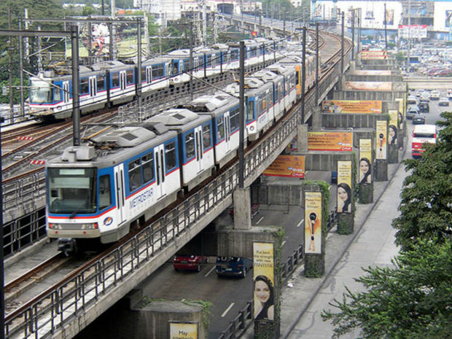
Step 1: Choosing the Right Photo
Not all photos can give the right miniature effect.
1) Choose a picture that was taken from a afar.
2) A good perspective is always a key point.
3) Cars, buildings and trees are the best, just make sure there's an element in the picture that would look good as a plastic toy model, for example a building or at least a few cars, trees or a structure.

Step 2:
After opening the image press the letter "Q" to enable Quick Mask Mode.

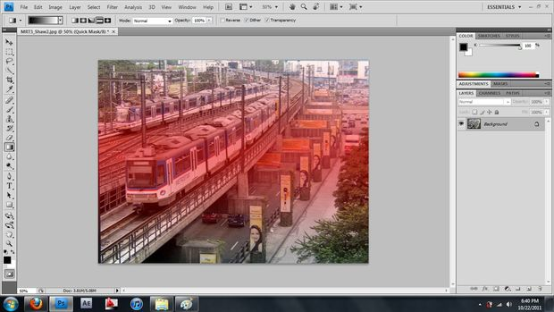
Step 3: Then press "G" to enable Gradient.
Choose the Reflected Gradient for the miniature effect.

Step 4:
After enabling "Gradient," draw a vertical line on the picture. A reddish color gradient will appear this marks the area of the picture you want in focus

Step 5:
Press on "Q" again to exit Quick Mask Mode.
This will make the marching ants selection lines appear.

Step 6:
After exiting the Quick Mode, go to
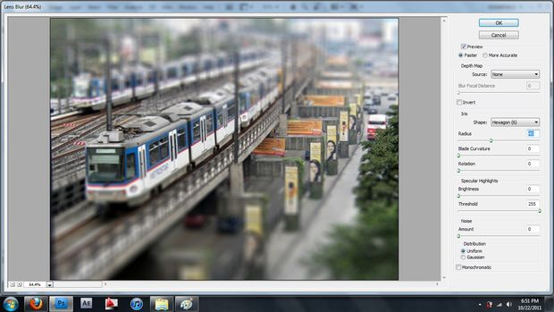
Filter > Blur > Lens Blur. Adjust the radius until you reach the desired output and press "OK”.
A radius of 40 is a good start.

Step 7: Press CTRL-D to remove the marching ants.

Step 8: Image > Adjustments > Hue and Saturation.
Move your saturation above 40.

Step 9: Image > Adjustments > Curves.
Step 10: Save As. Repeat steps for a total 4.
2 of your own images and 2 internet images.

