Tessellation Instructions

1. Select one photo from any assignment you have taken so far. Make all size and color adjustments before moving on.

**Size = 6 x 4.5 Resolution = 300 dpi Image > Adjustments > Curves**

1. http://anationofmoms.com/wp-content/uploads/2013/04/batch_cropping_image007.jpg**CROP IMAGE**

Select the **CROP TOOL** from the tool box

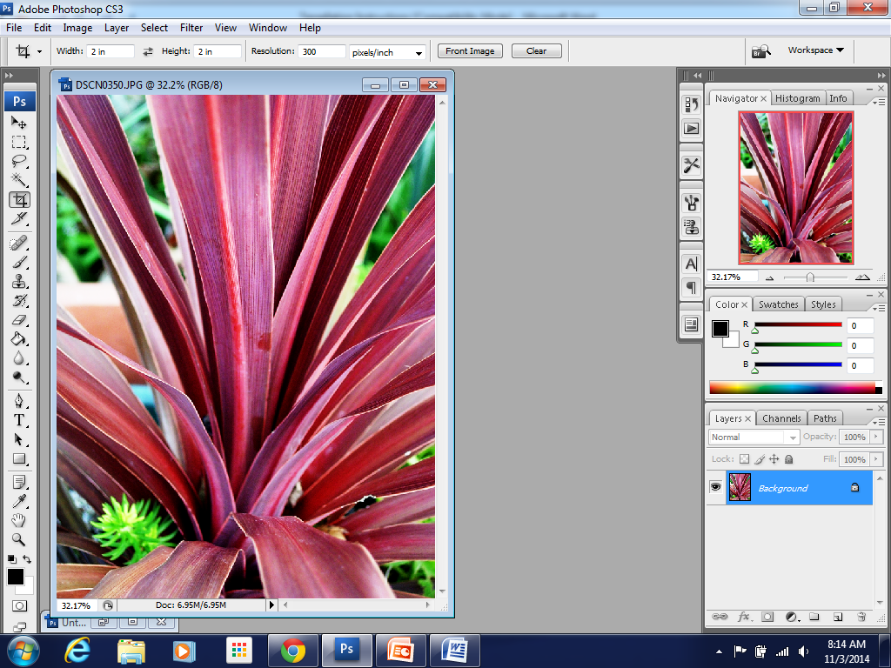Across the top tool bar change your dimensions.

**W = 2 inches**

**H = 2 inches**

**Resolution = 300**

Click and drag crawling ants to create a square. Move the selection to an area you would like to duplicate several times. Try and select an area with a diagonal line running through it.

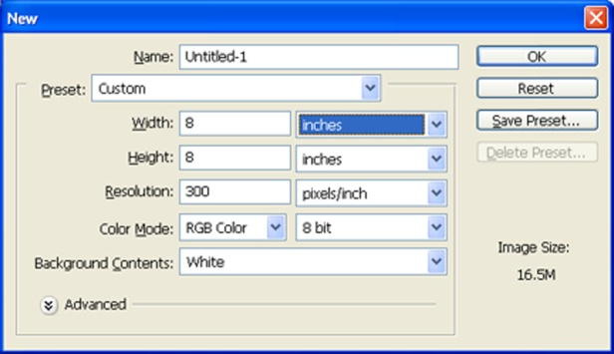

1. **CREATE A NEW DOCUMENT**

**FILE > NEW > 8 x 8 inches > Resolution = 300 dpi.**



1. **DRAG & DROP using the MOVE TOOL**

Move the **2 x 2** square of crawling ants from your original picture into the new **8 x 8 inch** document. **Repeat** this until you have **16 squares** in the new document.

1. 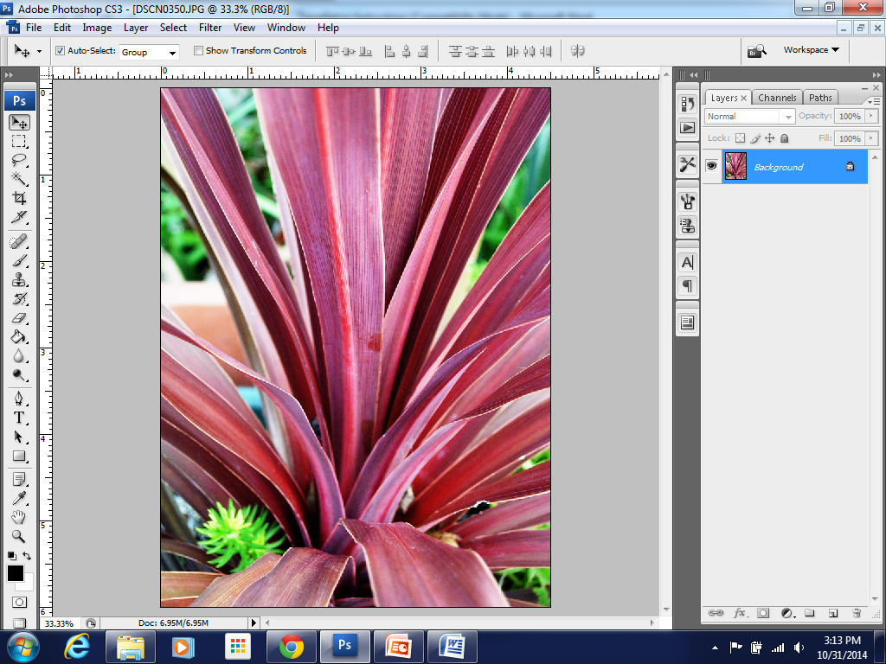**TRANSFORM INDIVIDUAL LAYERS AND ROTATE**

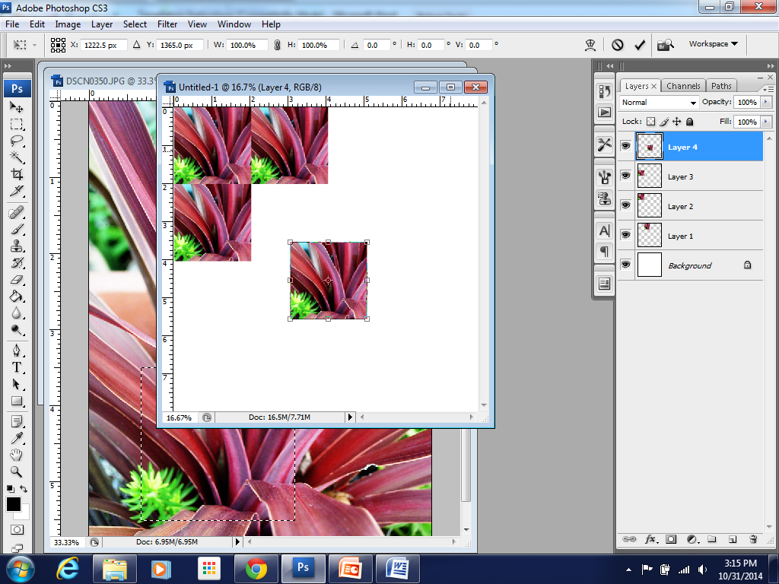Select the move tool . Turn auto select on in the top tool bar.

Click on photo to make layer active.

**EDIIT > TRANSFORM > ROTATE** or (**com T**)

Hit return to apply transformation.

**HOLD SHIFT** to constrain proportions.

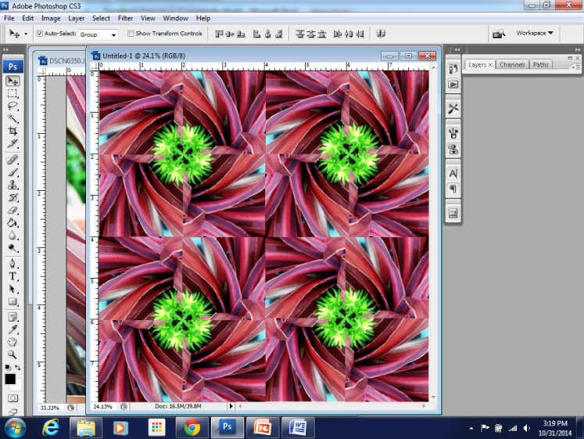

1. **ZOOM IN** to line up squares perfectly. (com + & com -)

Use the arrow keys to nudge picture left, right, up or down.

1. **Save one copy** as a **.PSD** so you can manipulate layers

**Save one copy** as a **.JPG** so you can upload to schoology.

**PRINT** one **COPY** for your sketchbook.

**REPEAT** with a different photo. Turn in a total of **two** tessellations.