The Study of Insects
A Project based on Composition and Drawing Techniques

This assignment is a comprehensive study and drawing of insects. Find one insect that interests you. Use magazines, books or the Internet to find your imagery. You may like a particular bug because you think it’s beautiful or maybe you dislike the insect because it’s creepy, or can harm you. No matter what, choose one and start drawing. Consider why you’ve chosen the bug you have. Go on-line and research several interesting facts about your creature. Try and find a unique insect, one that has character, texture and visual interest, avoid trite or overused imagery.

Process:
- Work from REFERENCE PHOTOS. Start by sketching several insect options. Draw at least 4 THUMBNAIL SKETCHES of different insects in your sketchbook.
- Select the insect you enjoyed drawing the most and on another page in your sketchbook attempt 4 DIFFERENT VANTAGE POINTS OF THE INSECT. For example, try a side view, aerial view, close up of the face, zoomed in view of the wings, eyes, or tail?
- Draw ONE final sketch; divide your page into 6 DIFFERENT SECTIONS of squares and rectangles. Twist and turn the boxes for an interesting composition.
- Now fill each section with a different viewpoint of your insect. NO TWO SQUARES CAN HAVE THE SAME DRAWING.
- Please use both OPEN and closed Compositions when drawing.
- One square can be TEXT. If it is, what will it say? Where will it go? Educate the viewer about your insect.
- The purpose of this project is to work on composition and your rendering of form and depth using different pencils types. You have the option of USING ONE pop of color with prismacolor pencils.
- SHOW ME your final sketch, with insects placed in the individual squares. I will give you the final paper and help you work out the minor details.

Requirements:
- Your final drawing must show SIX DIFFERENT VIEWPOINTS of your insect. This might include an angle from the side, front, belly back, close up or far away.
- Your drawing must include an equal amount of rich BLACKS, sharp GRAYS and crisp WHITES. Emphasize light and shadow!
- Use the expressive qualities of LINE to create VOLUME and DEPTH to your drawing.
- Consider your overall COMPOSITION. (The placement or arrangement of the elements on the page, the ingredients for a strong work of art.) Do not place your subject matter dead center in each square. Allow your imagery to fall off the sides of the box or hang into another section of the page. Zoom in and show only part of the insect. Let the viewer’s eye fill in the missing pieces.
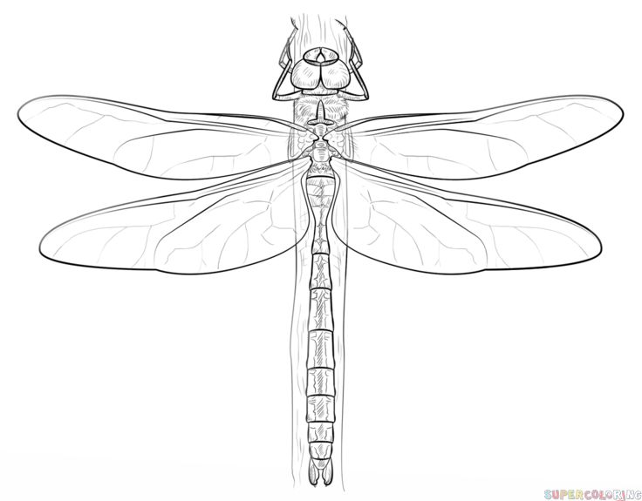
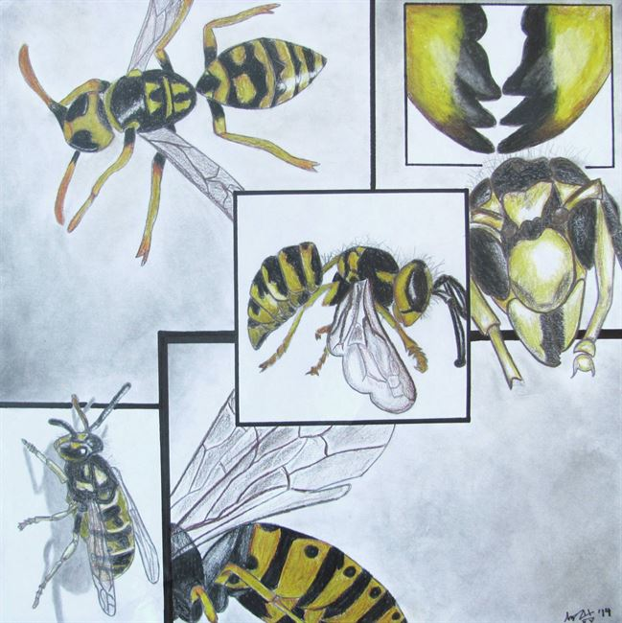
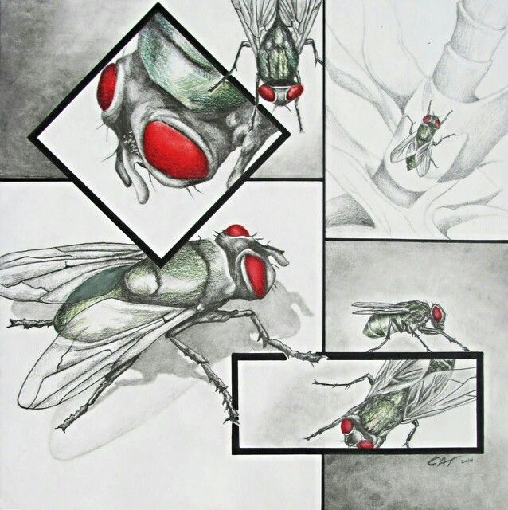
YES -Shading

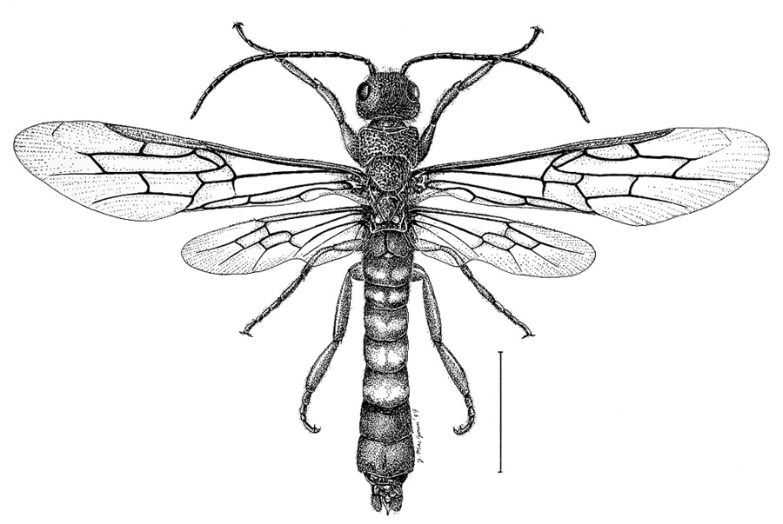

NO - Outlines

