Gradient Maps
- Open any photograph you have previously taken this quarter.
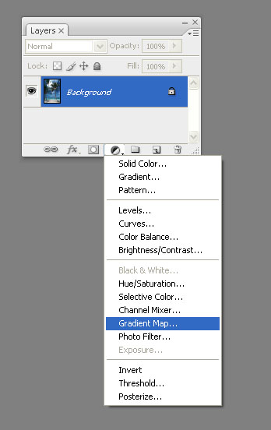
- Change your image size to 6 x 4.5 and make adjustments as needed.
- Create an Adjustment Layer. In the layers window select the half black/half white symbol at the bottom.

- Select GRADIENT MAP.

- Choose a Gradient Style. Remember there are more
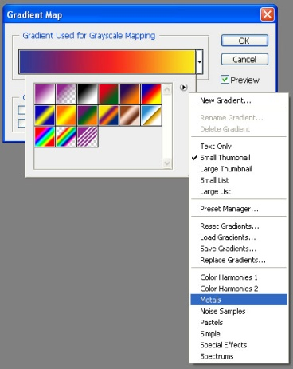
Gradients. Click on the black arrow to reveal more options. Select a Gradient that works well for your picture and hit OK.
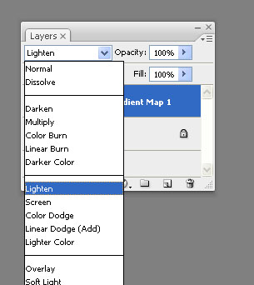

- In the layers window select a BLEND MODE that improves your photo and makes the colors pop! SAVE
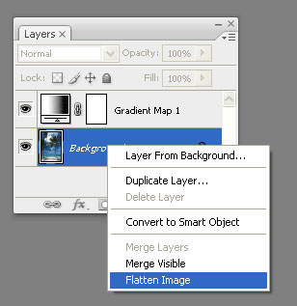
- Before printing your final images your layers need to be merged. In the layers window, right click on the text of the layer and select Flatten Image. This will put both layers onto one background and allow you to move the gradient image onto an 8x10 inch page to print. Do not forget to check your resolution of both your photo and the new document.

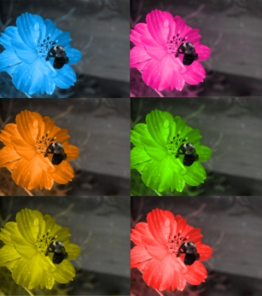
- Create FOUR unique gradient maps and turn them in for a grade. You do not need a contact sheet.

- Extra Credit: Without my help! Using your own photo can you create an image that looks like this? If so print a copy and show it to me.

